|  |  |
| --- | --- |
| Semester | T.E. Semester VI – Computer Engineering |
| Subject | Cloud Computing |
| Subject Professor In-charge | Prof. Divya Nimbalkar |
| Assisting Teachers | Prof. Divya Nimbalkar |

|  |  |
| --- | --- |
| Student Name | Deep Salunkhe |
| Roll Number | 21102A0014 |
| TE Division | A |

**Title:**

Study of Cloud Computing



**Implementation:**

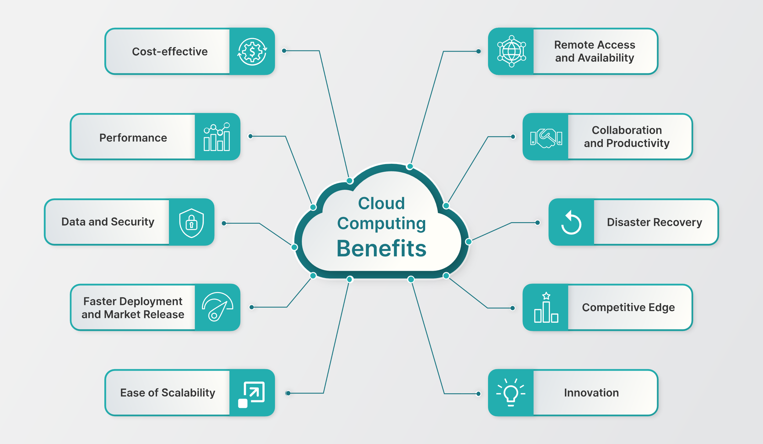

1. **Need for Cloud Computing:**

* **Scalability:** Cloud computing offers scalability, allowing businesses to easily scale resources up or down based on demand. This flexibility helps businesses handle varying workloads efficiently without over-provisioning or under-provisioning resources.
* **Cost Efficiency:** Cloud computing eliminates the need for upfront investment in hardware and infrastructure. Instead, businesses pay for the resources they use on a pay-as-you-go basis. This cost-effective model reduces capital expenditure and allows businesses to allocate resources more effectively.
* **Accessibility:** Cloud computing enables remote access to data and applications from any location with an internet connection. This accessibility promotes collaboration among geographically dispersed teams and facilitates remote work, enhancing productivity and flexibility.
* **Reliability and Disaster Recovery:** Cloud providers offer robust infrastructure with redundant systems and data backups, ensuring high availability and reliability. In the event of hardware failure or natural disasters, cloud-based backups enable quick recovery of data and applications, minimizing downtime and data loss.
* **Innovation and Agility:** Cloud computing provides access to a wide range of services, tools, and technologies, enabling rapid experimentation and innovation. Businesses can quickly deploy new applications, experiment with emerging technologies, and adapt to changing market conditions, fostering agility and competitiveness.

1. **NIST Model of Cloud Computing:**

* The National Institute of Standards and Technology (NIST) defines cloud computing as a model for enabling ubiquitous, convenient, on-demand network access to a shared pool of configurable computing resources (e.g., networks, servers, storage, applications, and services) that can be rapidly provisioned and released with minimal management effort or service provider interaction.
* NIST identifies five essential characteristics of cloud computing:
  1. **On-demand self-service:** Users can provision computing resources (e.g., servers, storage) automatically without human intervention from the service provider.
  2. **Broad network access:** Services are accessible over the network via standard mechanisms, enabling ubiquitous access from various devices and platforms.
  3. **Resource pooling:** Cloud resources are pooled together to serve multiple users, with dynamic allocation based on demand. Users typically have no control or knowledge over the exact location of the resources.
  4. **Rapid elasticity:** Cloud resources can be rapidly scaled up or down to meet changing demands. This elasticity allows resources to be provisioned and released automatically, often in real-time.
  5. **Measured service:** Cloud usage is monitored, controlled, and reported transparently, enabling pay-per-use billing and resource optimization.

1. **Deployment Models of Cloud Computing:**

* **Public Cloud:** Public cloud services are owned and operated by third-party cloud service providers, who deliver computing resources (e.g., servers, storage, networking, applications) over the internet to multiple users. These services are available to the general public on a pay-as-you-go basis. Examples include Amazon Web Services (AWS), Microsoft Azure, and Google Cloud Platform (GCP).
* **Private Cloud:** Private cloud infrastructure is dedicated to a single organization and is typically hosted either on-premises or in a third-party data center. Unlike public cloud, private cloud resources are not shared with other organizations, providing greater control, security, and customization. Private clouds are suitable for organizations with strict regulatory requirements or sensitive data.
* **Hybrid Cloud:** Hybrid cloud combines elements of both public and private cloud environments, allowing data and applications to be shared between them. Organizations can leverage the scalability and cost-effectiveness of public cloud for non-sensitive workloads while keeping sensitive data and critical applications in a private cloud for security and compliance reasons. Hybrid cloud offers flexibility and allows organizations to optimize their IT infrastructure based on workload requirements.

1. **Service Models of Cloud Computing:**

* **Infrastructure as a Service (IaaS):** IaaS provides virtualized computing resources over the internet, including virtual machines, storage, and networking. Users can deploy and manage their own operating systems, applications, and middleware, while the cloud provider manages the underlying infrastructure (e.g., servers, storage, networking). IaaS offers scalability, flexibility, and cost savings by eliminating the need for physical hardware and infrastructure maintenance.
* **Platform as a Service (PaaS):** PaaS offers a platform and development environment with tools and services for building, testing, deploying, and managing applications over the internet. Developers can focus on coding and application development, while the PaaS provider handles infrastructure management, scalability, and runtime environments. PaaS accelerates application development, reduces time to market, and simplifies the deployment and management of applications.
* **Software as a Service (SaaS):** SaaS delivers software applications over the internet on a subscription basis, allowing users to access and use software applications hosted on the cloud without the need for installation or maintenance. SaaS providers manage the infrastructure, databases, and application software, while users access the applications through web browsers or APIs. SaaS offers convenience, scalability, and cost savings by eliminating the need for software installation, updates, and maintenance.



**Conclusion:**

In conclusion, cloud computing offers numerous benefits, including scalability, cost efficiency, accessibility, reliability, and agility. Understanding the NIST model, deployment models (public, private, hybrid), and service models (IaaS, PaaS, SaaS) of cloud computing is essential for organizations to leverage cloud technologies effectively and drive innovation and competitiveness in today's digital landscape.